**Article ID:** [4203] How to add rinse aid to my dishwasher.

**Article name:** How to add rinse aid to my dishwasher.

**Topic location:** Dishwasher / Cleaning & Maintenance

**Metadata:** filling

**RFC:**

**Related articles:**

**Related questions:**

PNC

DIY

Safety

Link

Email

Book Engineer

Multimedia

Brand

**Article content:**

**WSS**

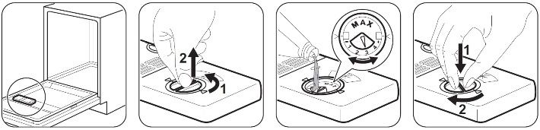

Fill the rinse aid dispenser until the unit is full.

Remove any spilled rinse aid with an absorbent cloth to prevent too much foam.

To adjust the quantity of rinse aid released, turn the selector between position 1 (lowest quantity) and position 4 (highest quantity).

The rinse aid helps to dry the dishes without streaks and stains during the last rinsing phase.

Only use salt, rinse aid and detergent for dishwashers. Other products can cause damage to the appliance.

Please refer to your User Manual for further assistance and for specific information on your model.